# SQL Chapter 1

To View the tables in a DB,

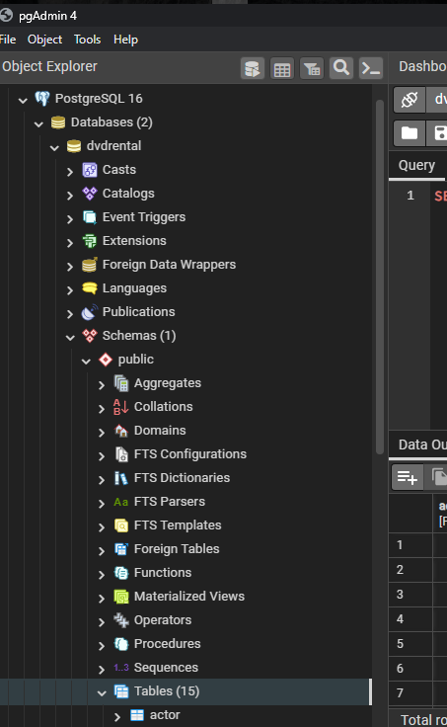

Viewing all contents of a table

SELECT * FROM table_name;

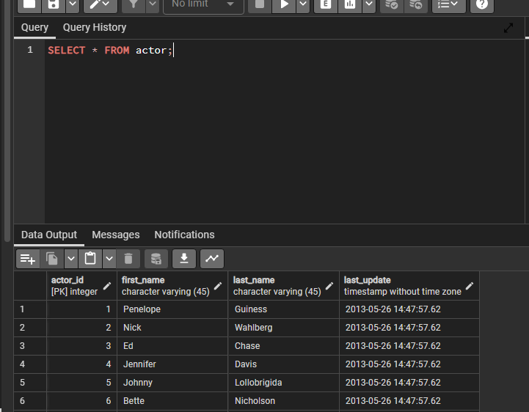

If only one column is required

SELECT first_name FROM actor;

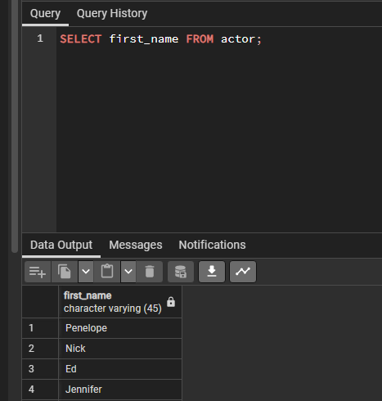

Get multiple data

SELECT first_name,last_name,email FROM customer;

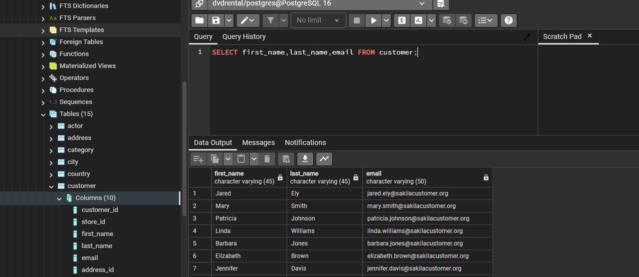

DISTINCT KEYWORD

SELECT DISTINCT column FROM table

OR

SELECT DISTINCT(col) FROM table

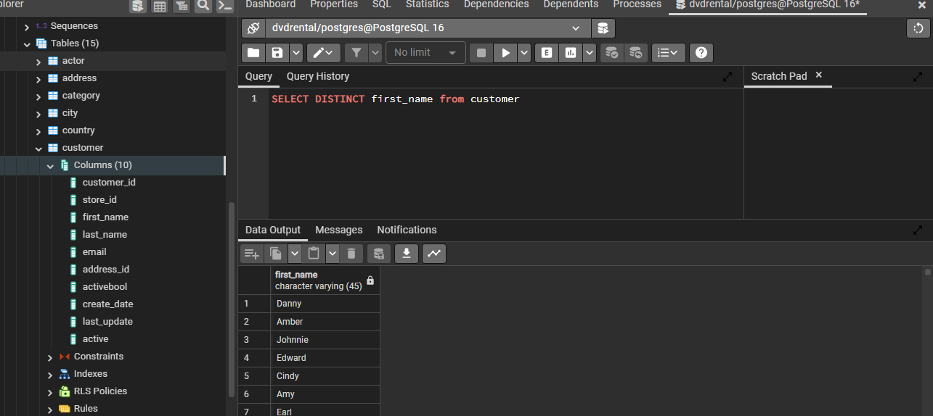

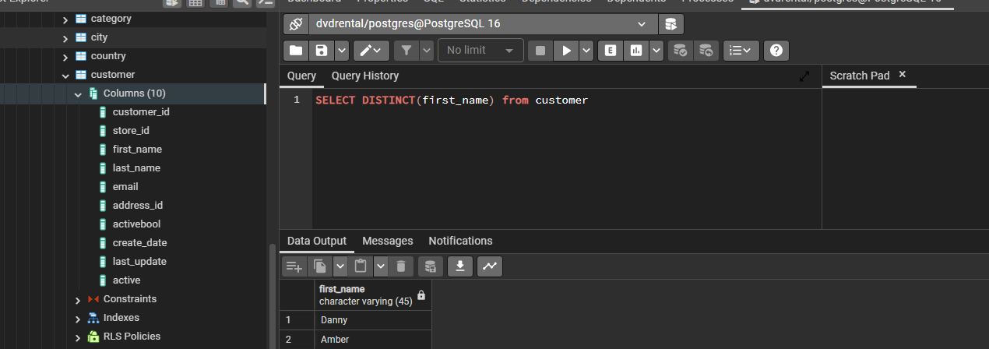

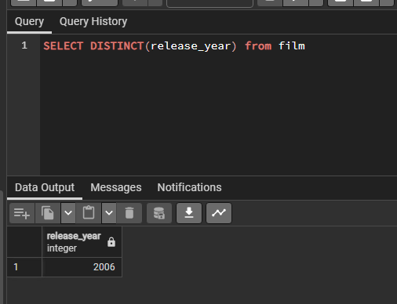

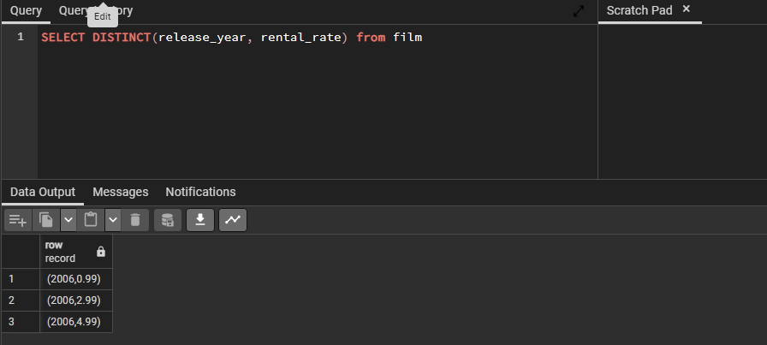

COUNT Keyword

SELECT COUNT(DISTINCT(rating)) FROM film

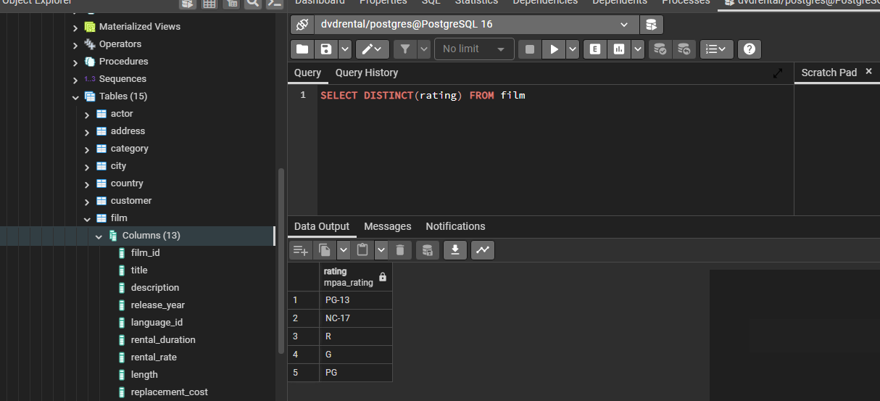

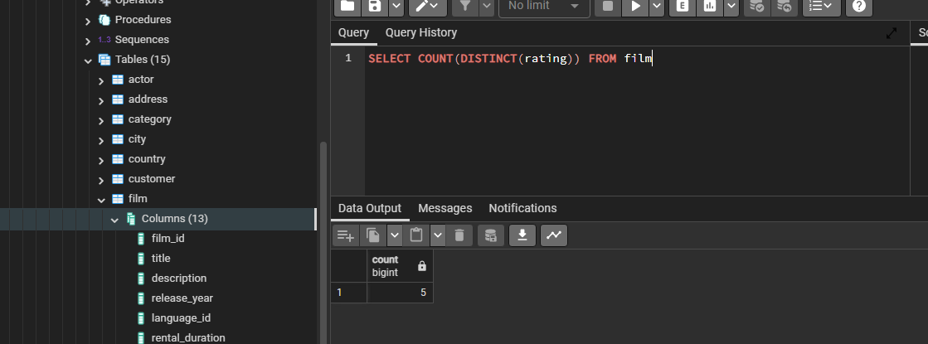

#### SELECT WHERE KEYWORD

SELECT col1, col2 FROM table WHERE condition

Conditions can be made using comparison operators :

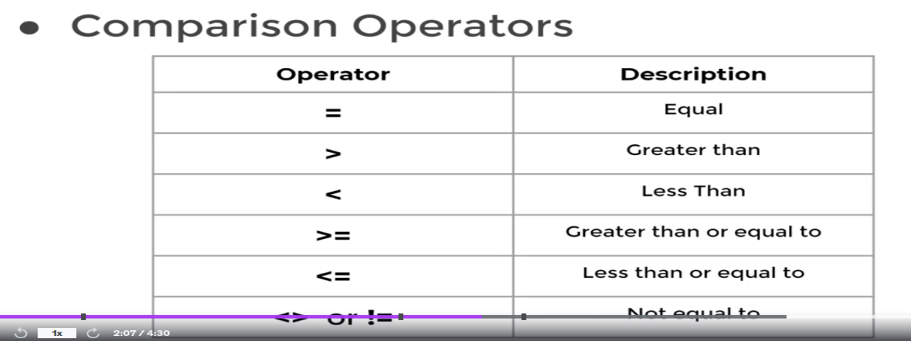

Logical Operators : AND, OR, NOT

SELECT * from actor WHERE first_name='Johnny'

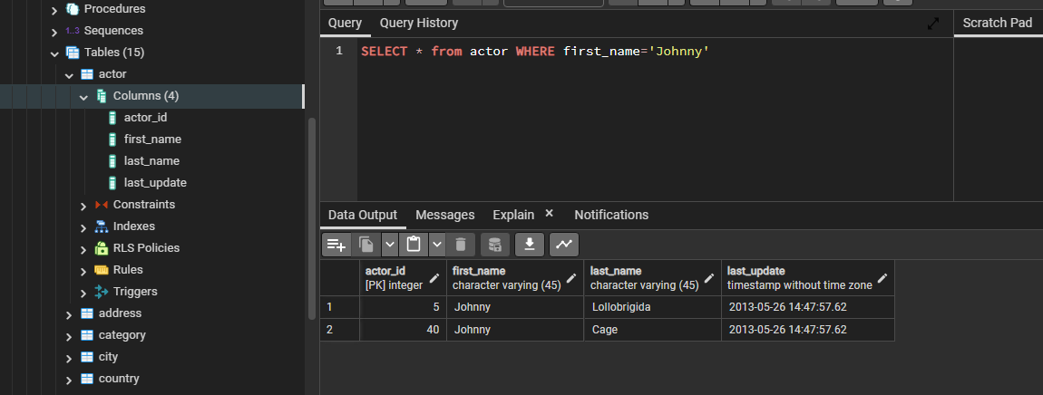

SELECT actor_id,last_update,first_name from actor WHERE first_name='Johnny'

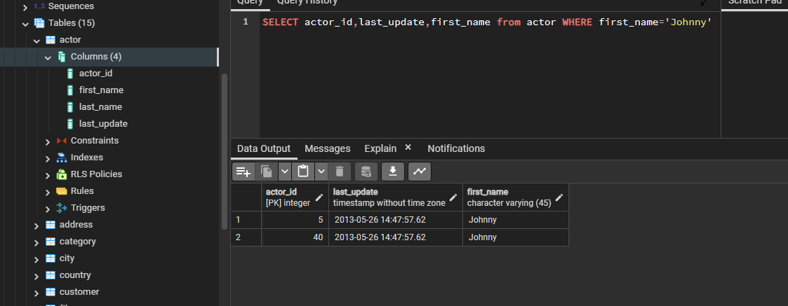

SELECT * from actor WHERE first_name='Johnny' AND last_name='Cage';

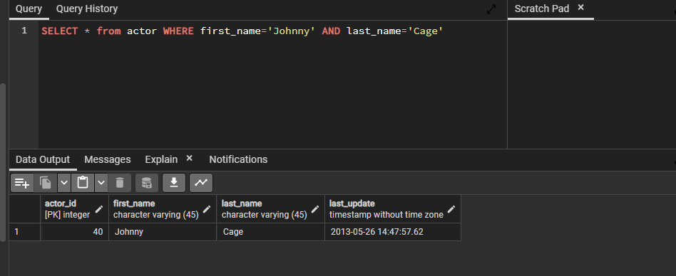

SELECT * FROM film

WHERE rental_rate >= 4;

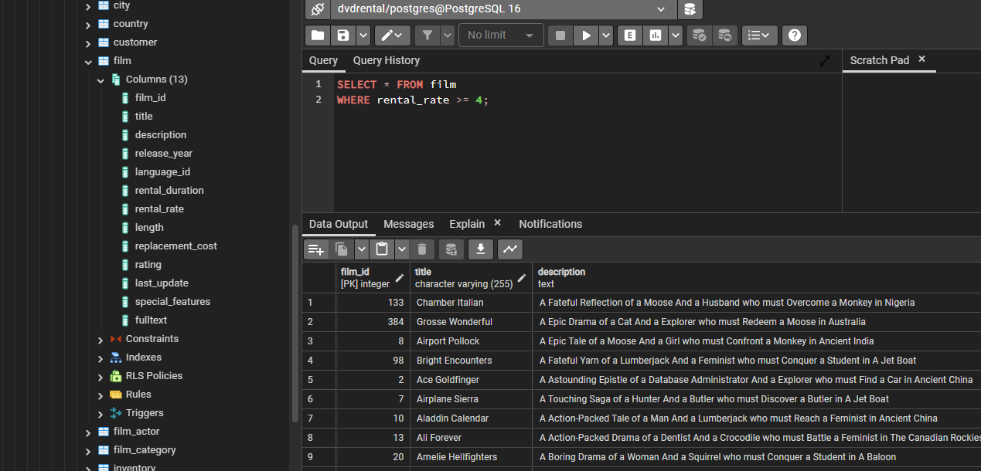

SELECT * FROM film

WHERE rental_rate >= 4 AND replacement_cost >= 14.5;

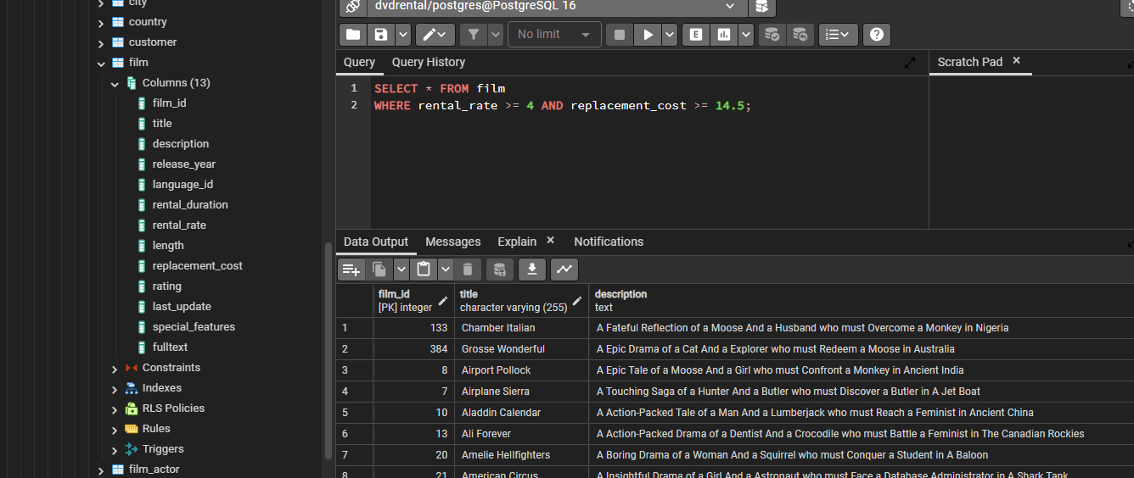

SELECT *

FROM FILM

WHERE RENTAL_RATE >= 4

AND REPLACEMENT_COST >= 14.5

AND RATING = 'R';

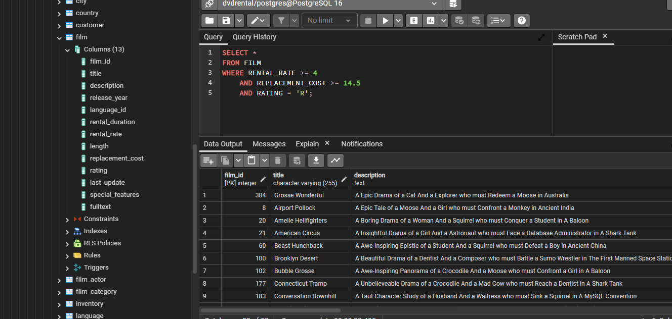

SELECT COUNT(*)

FROM FILM

WHERE RENTAL_RATE >= 4

AND REPLACEMENT_COST >= 14.5

AND RATING = 'R';

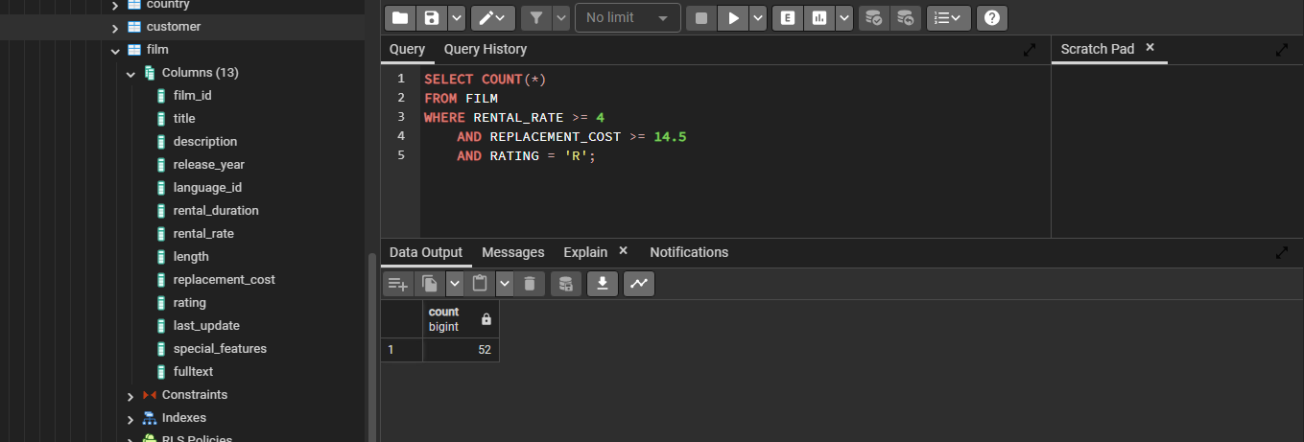

SELECT COUNT(*)

FROM FILM

WHERE RENTAL_RATE >= 4

AND REPLACEMENT_COST >= 14.5

AND RATING = 'R'

OR RATING = 'PG-13';



## ORDER BY

SELECT col1,col2 FROM table ORDER BY col1 ASC/DESC

If we leave it blank, ASC by default

SELECT * FROM customer ORDER BY first_name;

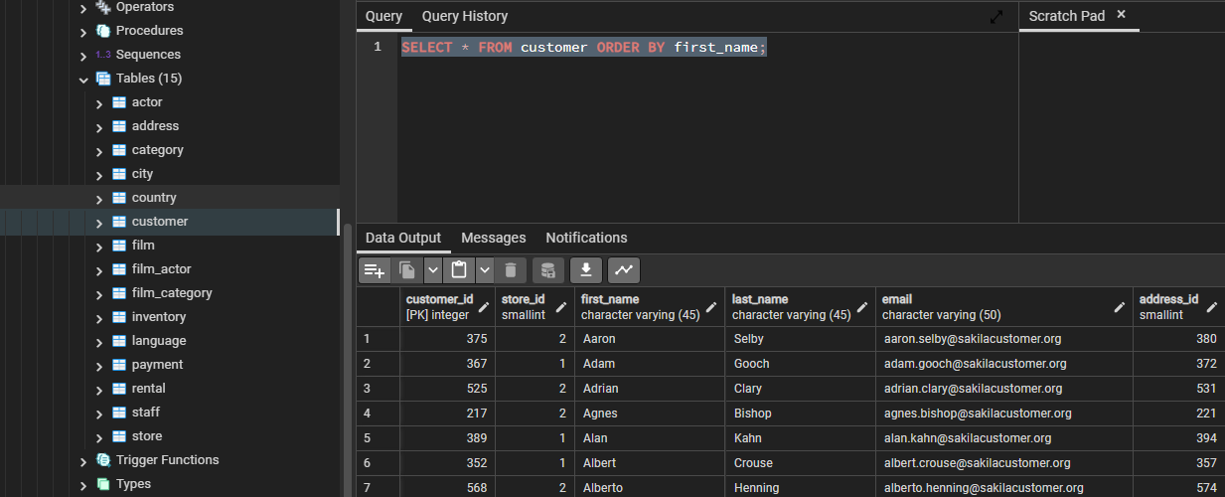

SELECT * FROM customer ORDER BY first_name DESC;

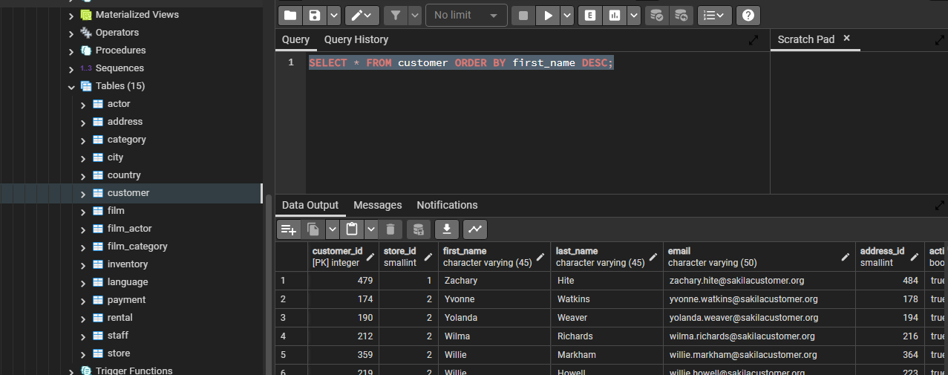

SELECT STORE_ID,

FIRST_NAME,

LAST_NAME

FROM CUSTOMER

ORDER BY STORE_ID,

FIRST_NAME;

Here first sort by store_id, then sort by firstname



SELECT STORE_ID,

FIRST_NAME,

LAST_NAME

FROM CUSTOMER

ORDER BY STORE_ID ASC,

FIRST_NAME DESC;

Sorts first in ascending store_id and then descending firstname

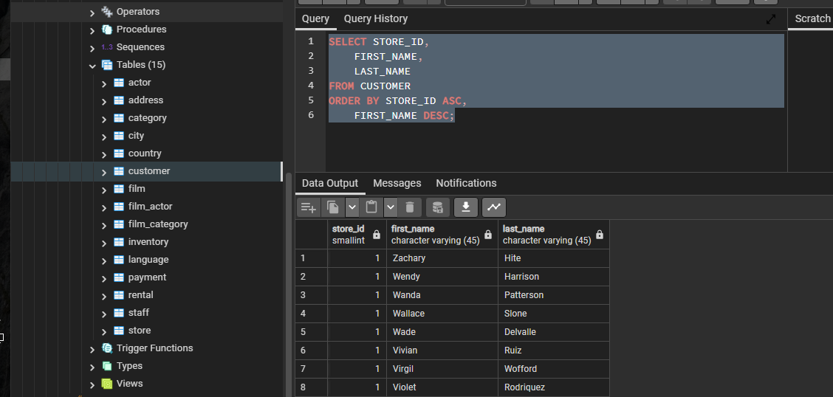

### LIMIT Keyword

Limit the number of rows

SELECT STORE_ID,

FIRST_NAME,

LAST_NAME

FROM CUSTOMER

ORDER BY STORE_ID ASC,

FIRST_NAME DESC

LIMIT 5;

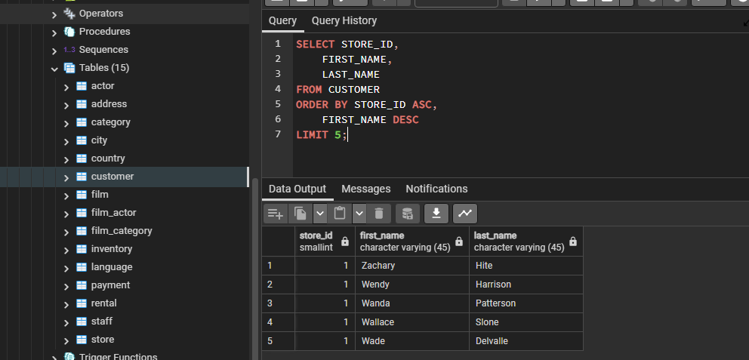

### BETWEEN Keyword

SELECT * FROM payment WHERE amount BETWEEN 8 AND 9;

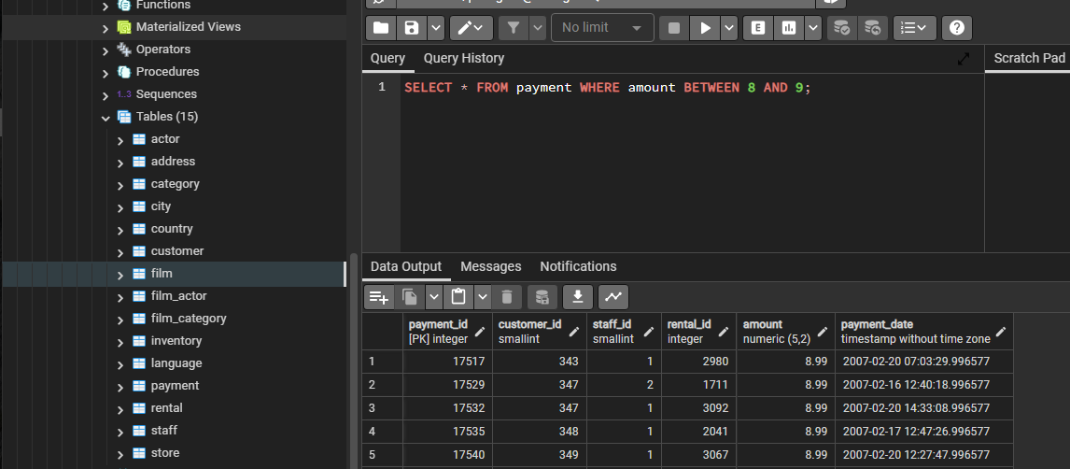

SELECT COUNT(*) FROM payment WHERE amount BETWEEN 8 AND 9 ;

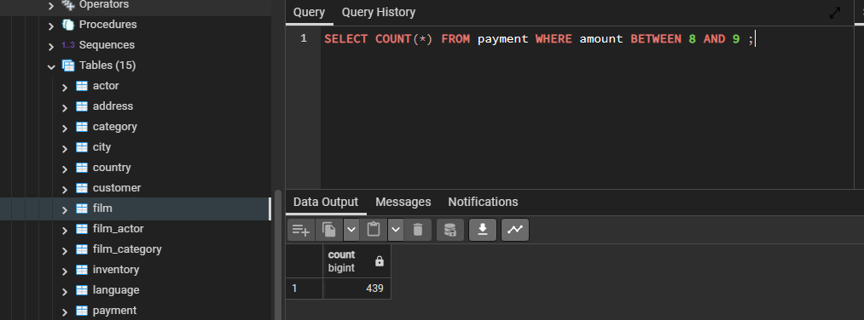

SELECT *

FROM PAYMENT

WHERE PAYMENT_DATE BETWEEN '2007-02-01' AND '2007-02-15'

ORDER BY AMOUNT

LIMIT 4;

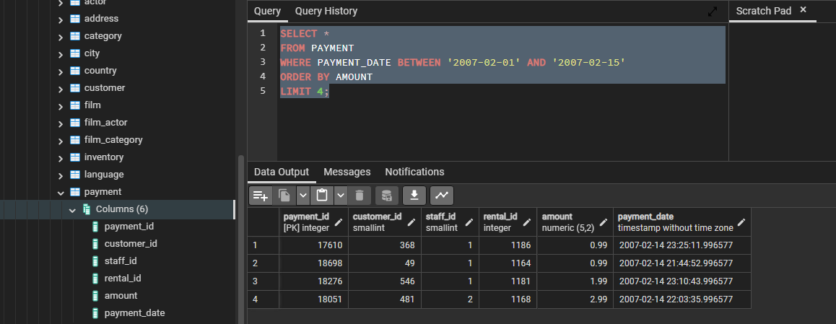

### LIKE and ILIKE Keyword

Like allows us to use pattern matching in SQL (% - matches any sequence of characters, ‘_’ matches any single character)

LIKE is case sensitive & ILIKE is case insensitive

SELECT first_name from customer WHERE first_name LIKE 'J%';

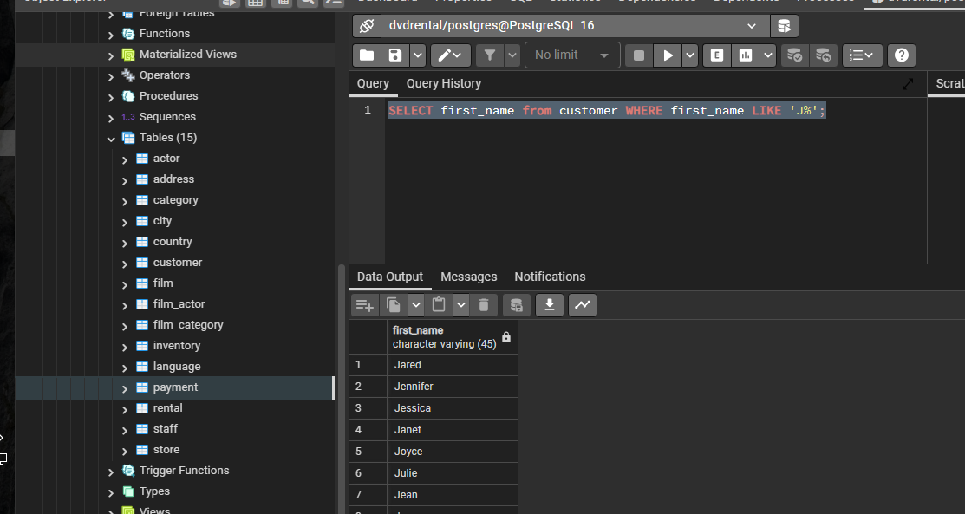

SELECT first_name from customer WHERE first_name LIKE 'J_';

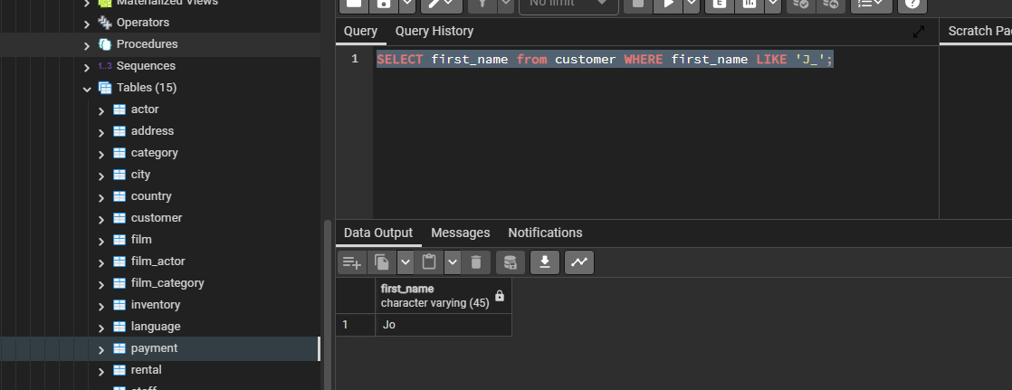

SELECT first_name from customer WHERE first_name LIKE 'J__';

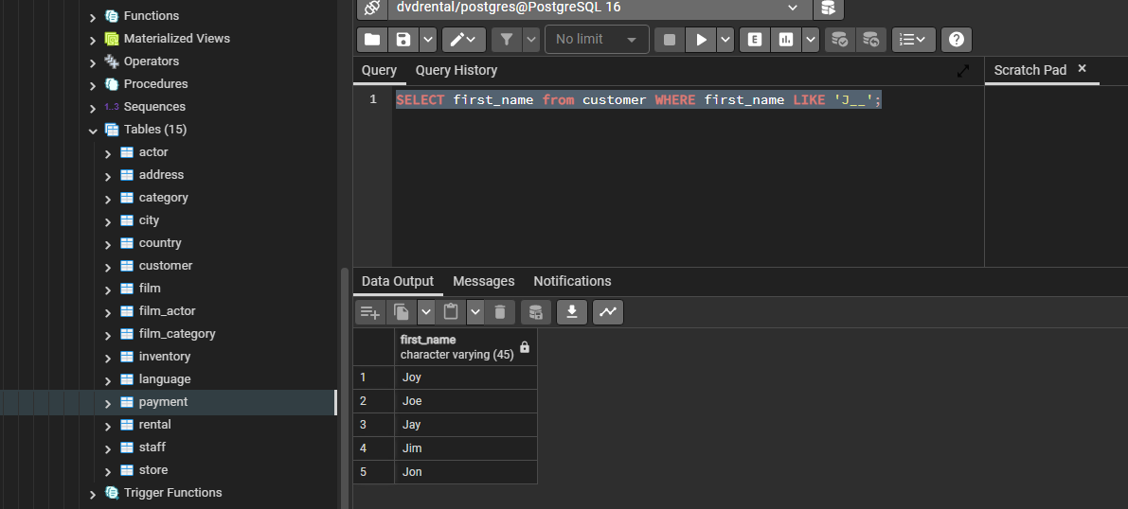

SELECT first_name from customer WHERE first_name LIKE '__h%';

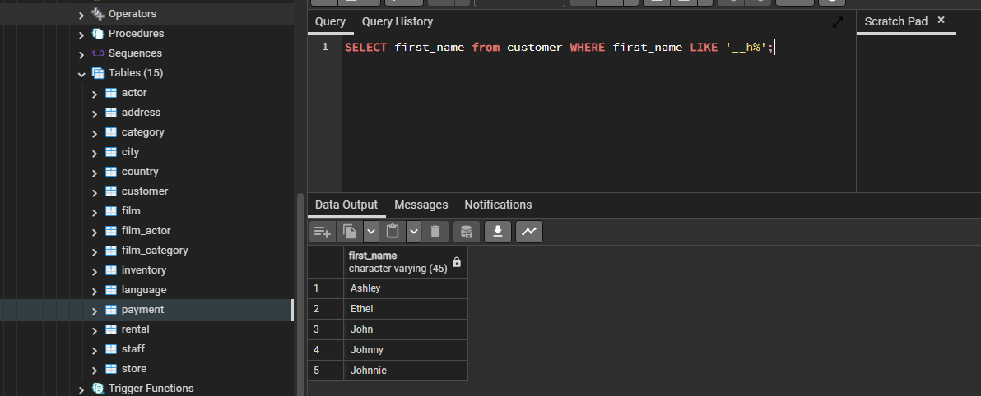

### Aggregate Functions

* AVG()
* COUNT()
* MAX()
* DATE()
* MIN()
* SUM()

Works only in SELECT and HAVING

MIN()

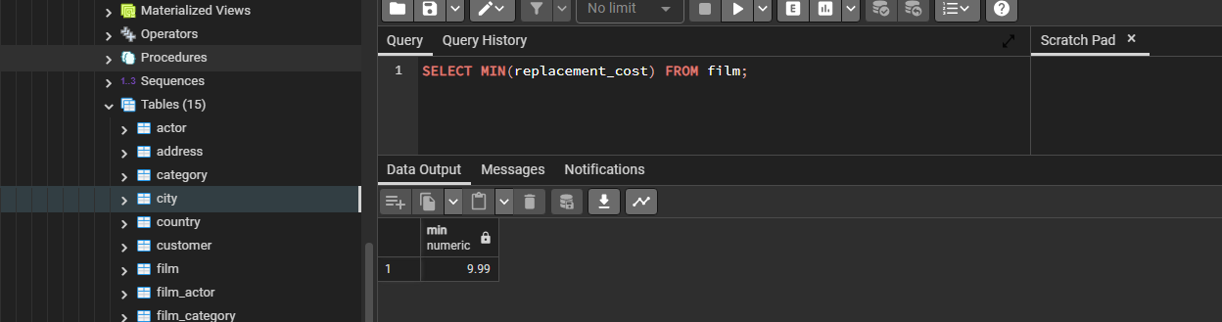

MAX()





AVG()



ROUND()

Syntax : ROUND(val, dec places)

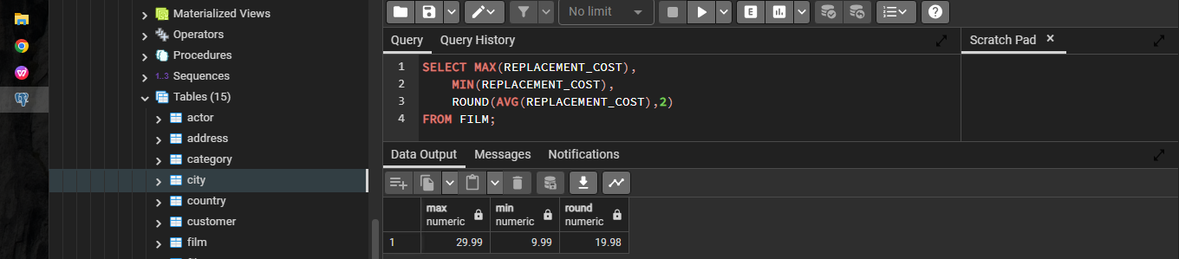

SUM()

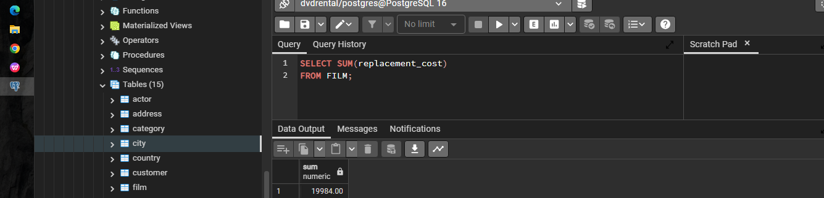

### GROUP BY Keyword

Syntax:

SELECT category_col, AGG(data_col) FROM table GROUP BY category_col

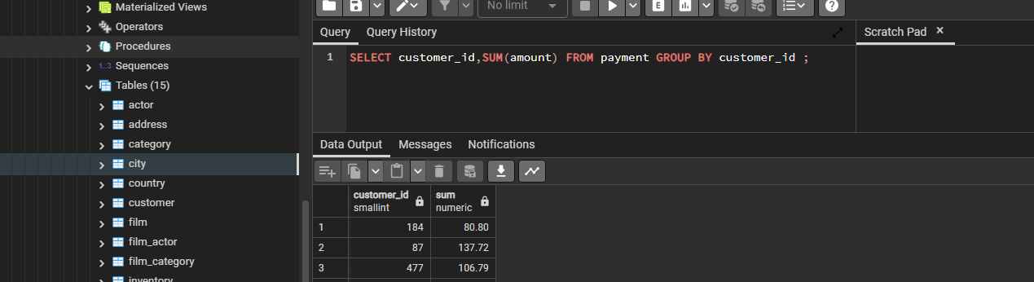

SELECT customer_id,SUM(amount) FROM payment GROUP BY customer_id ;

Shows the total amount spend by each customer

Getting the count of transactions of each customer

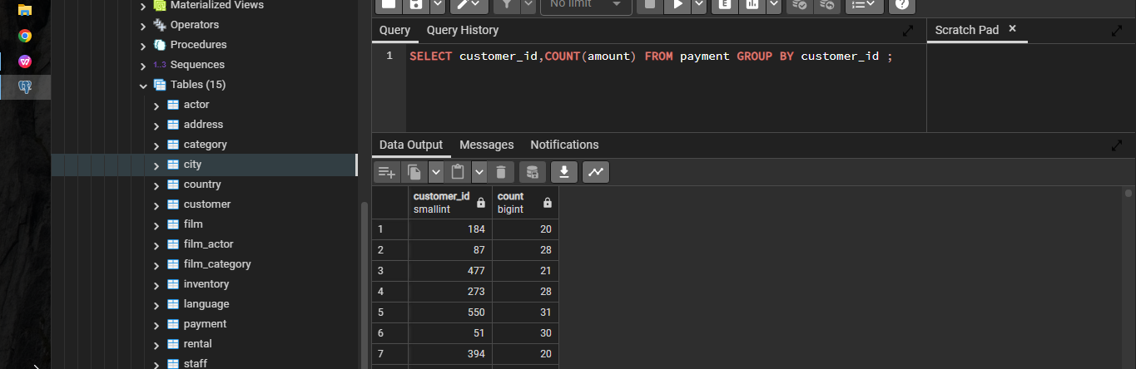

SELECT CUSTOMER_ID,

STAFF_ID,

SUM(AMOUNT)

FROM PAYMENT

GROUP BY STAFF_ID,

CUSTOMER_ID

ORDER BY CUSTOMER_ID;

This shows sales done by each customer with each staff

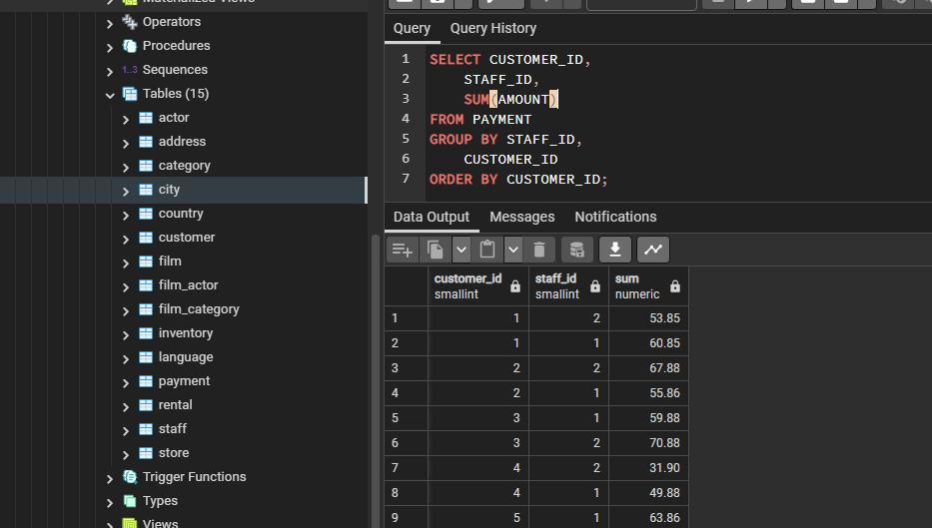\

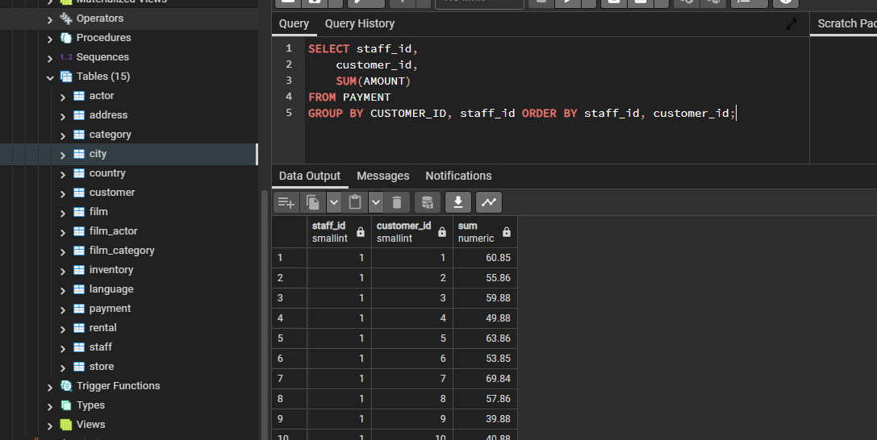

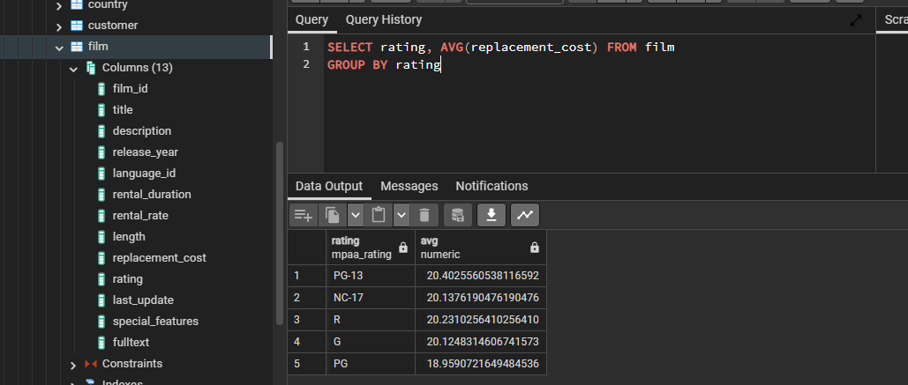

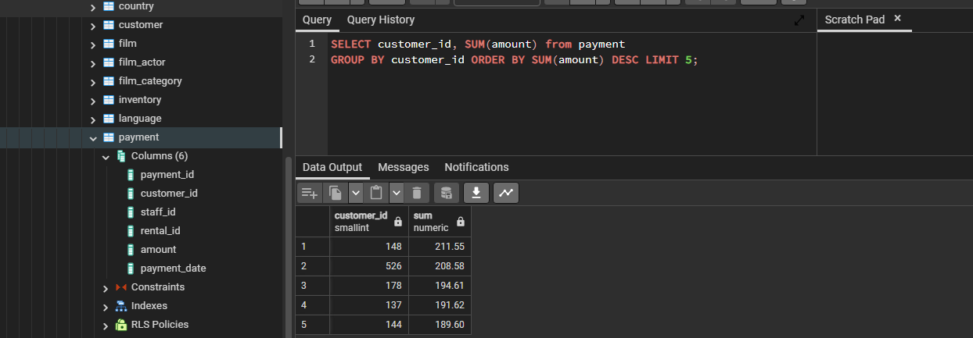

## HAVING Keyword

Allows to filter after an aggregation is over.

SELECT customer_id,SUM(amount) FROM payment

GROUP BY customer_id

HAVING SUM(amount) > 100

SELECT store_id, count(customer_id) from customer

GROUP BY store_id

HAVING count(customer_id) > 300

## **JOINS**

**AS Statement**

AS is used to give aliases

SELECT SUM(amount) AS net_revenue FROM payment;

AS gets executed at the end of a query so it cannot be used within WHERE Operator

SELECT COUNT(amount) AS num_transactions FROM payment;

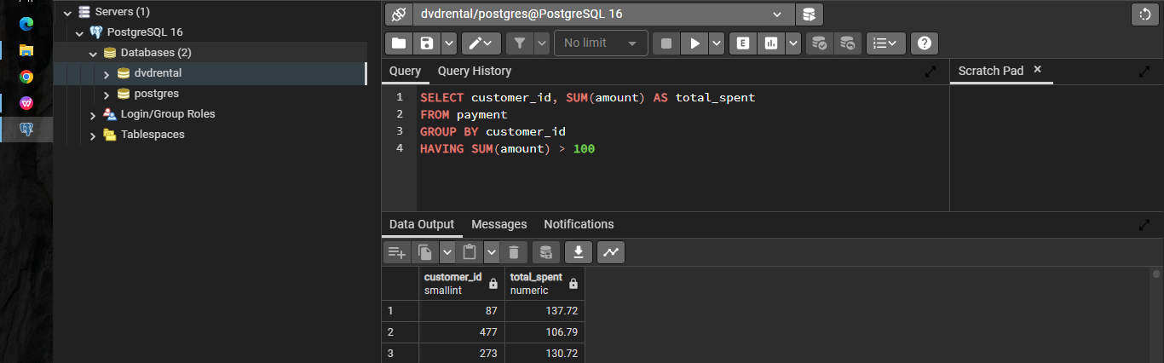

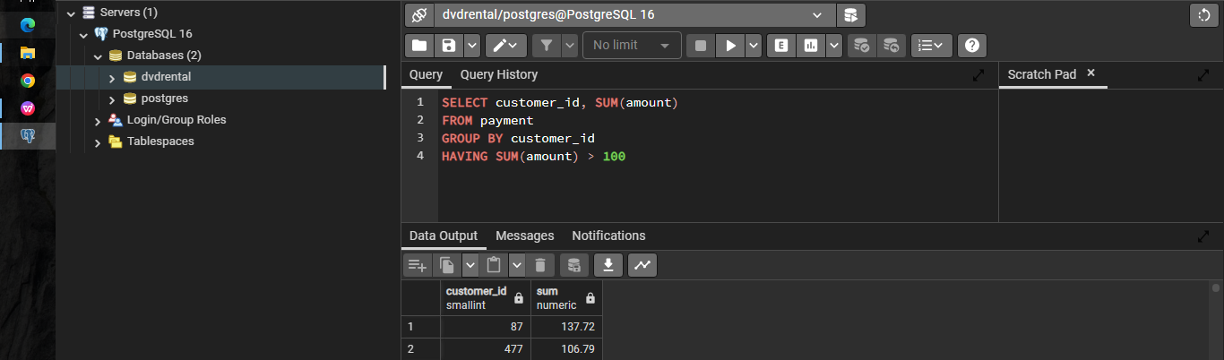

## INNER JOIN

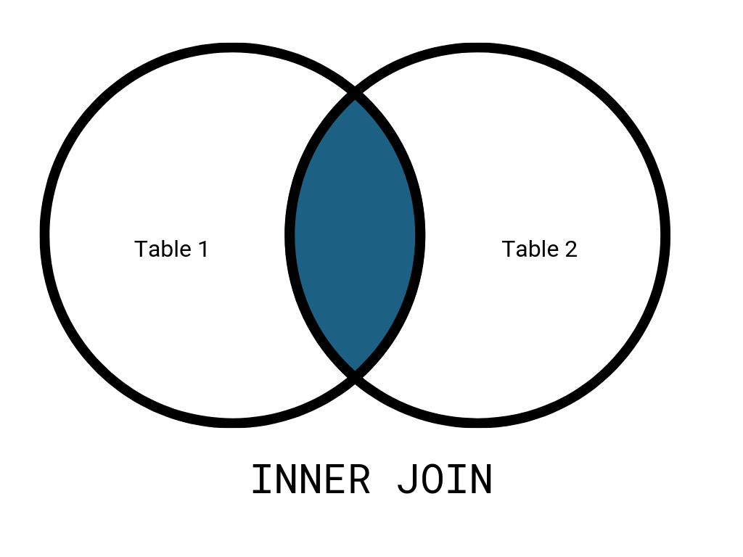

JOINS allow to combine multiple tables

SELECT * FROM TableA INNER JOIN TableB

ON TableA.col_match = TableB.col_match

*SELECT * FROM payment INNER JOIN customer*

*ON payment.customer_id = customer.customer_id*

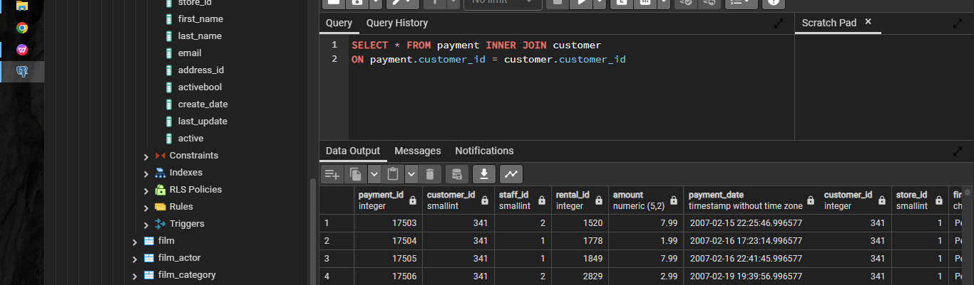

*SELECT payment.customer_id, payment.amount FROM payment INNER JOIN customer*

*ON payment.customer_id = customer.customer_id*

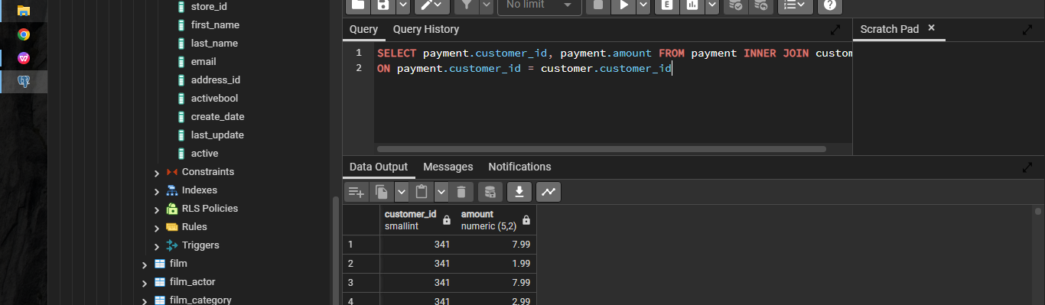

*SELECT payment.customer_id, customer.first_name, payment.amount FROM payment INNER JOIN customer*

*ON payment.customer_id = customer.customer_id*

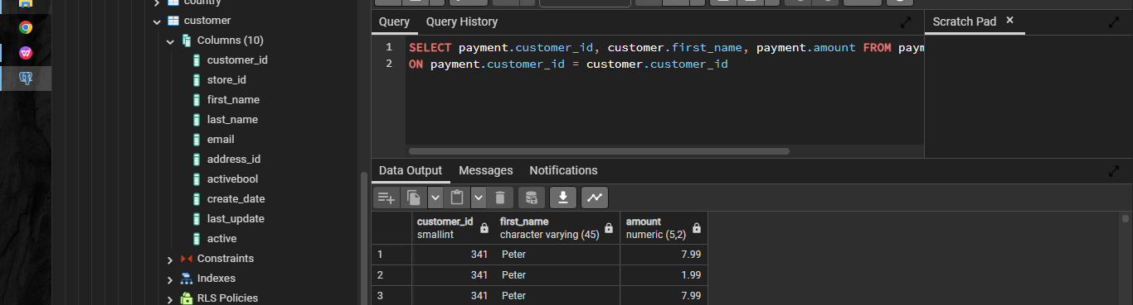

## OUTER JOINS

Opposite of Inner Joins

Three types… FULL OUTER JOIN, LEFT OUTER JOIN, RIGHT OUTER JOIN

## FULL OUTER Join

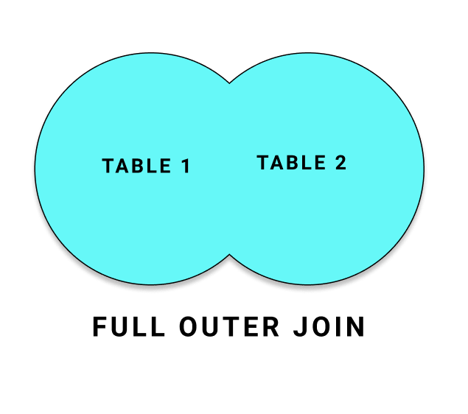

SELECT PAYMENT.CUSTOMER_ID,

CUSTOMER.FIRST_NAME,

PAYMENT.AMOUNT

FROM PAYMENT

FULL OUTER JOIN CUSTOMER ON PAYMENT.CUSTOMER_ID = CUSTOMER.CUSTOMER_ID

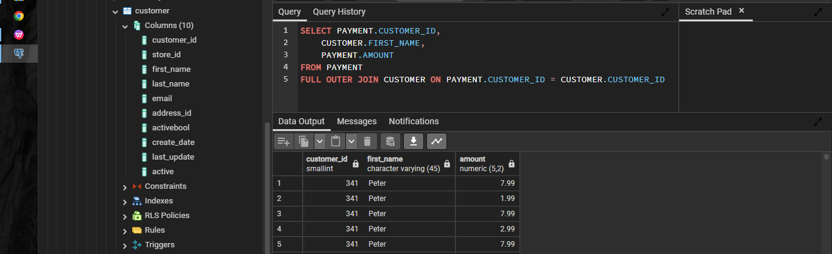

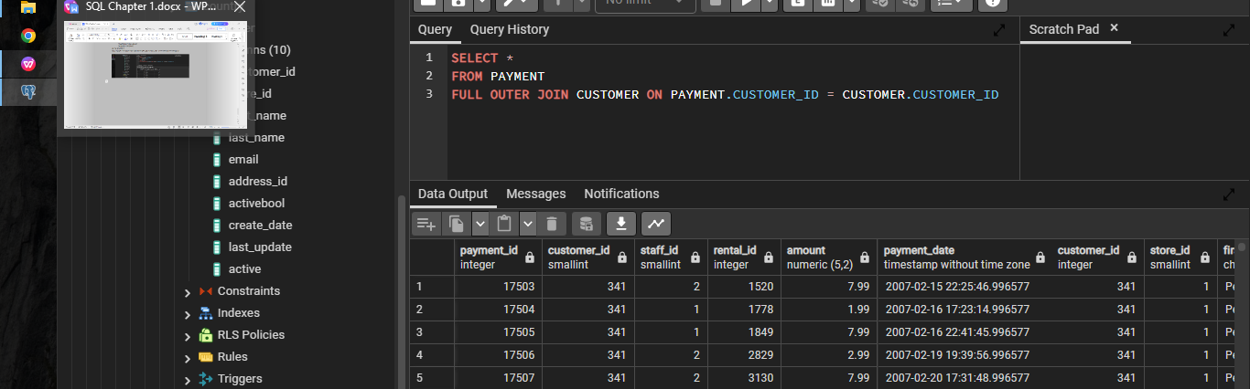

## LEFT OUTER JOIN